Science 9 – Unit 4 Review

*Recognized that the nucleus of a cell contains genetic information and determines cellular processes*

* **A Trait**  is a particular feature that can vary in an individual of a species, such as hair colour, eye colour and height
* **Heredity** is the process by which traits are passed on from one generation to the next (parents to children)

**The Nucleus** of the cell is the part of the cell that is responsible for heredity. The nucleus contains **DNA** which are the instructions that make you who you are.

* **DNA**  is short for Deoxyribonucleic Acid, and is a molecule that looks like a ‘twisted ladder’
* 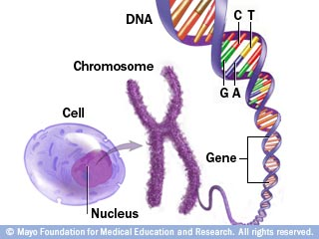Large amounts of DNA make up **Genes**, which are specific instructions about a particular trait, ex. Your eye colour
* Genes are stored on chromosomes, which are X shaped structures that are made of genes. Therefore, since genes are made of DNA, a chromosome is made up of huge amounts of DNA coiled together.
* A comparison for DNA, Genes and Chromosomes is to that of a book. All the information in your body is like a book of instructions. Each chromosome is like a chapter of that book. The genes are like paragraphs of the chapter, and DNA are the words that make up sentences.

*Discuss Factors that may lead to changes in a cell’s genetic information*

* A **Gene Mutation** is a change to DNA. When DNA is mutated, the meaning of the Genes can change. Similar to how changing one letter of a word can change its meaning, changing DNA can affect the instructions for your body.
* Mutations are caused by **Mutagens**, which are things in the environment that can change DNA. Mutagens come in 2 main forms:
  + - * Natural Mutagens – Solar Radiation (Sunburns), Natural Radiation from the earth
      * Human Mutagens – Chemical (like smoking) , nuclear radiation
* Mutations can be beneficial in some cases, but the main concern today for humans is that many mutations cause **cancer** to form, by changing DNA to form cancer cells.

*Illustrate and Describe the basis process of cell division, including what happens to the cell membrane and contents of the nucleus*

* **The Cell Cycle** is the process whereby cells reproduce. The cell cycle has three main steps:
* **Interphase:**
  + Interphase is the longest part of the cell cycle, and two very important processes take place. The cell **replicates DNA** so when the cell divides it has a copy of DNA for each new cell. The cell also grows in size.
* **Mitosis:**

Mitosis is the process where a single cell nucleus splits and forms 2 nuclei. It has 4 main parts:

* 1. Prophase - The DNA coils to form chromosomes, and the nuclear membrane breaks down.
  2. Metaphase - The chromosomes line up along the middle of the cell
  3. Anaphase - The chromosomes are pulled apart, so each new cell gets a copy of the chromosome.
  4. Telophase - A nucleus forms around each new set of chromosomes.
* **Cytokinesis:**

After a cell has undergone mitosis, the two new **daughter cells** split apart to form 2 genetically identical cells. After the cells divide they will return to interphase and continue the cycle.

When cells are going through the cell cycle, there are **checkpoints** in the cell that help to make sure that the cell will be successful before it tries to divide. A cell will not divide if:

* The cell does not have enough nutrients to be successful in cell division
* The cell has not replicated the DNA yet
* The DNA becomes damaged

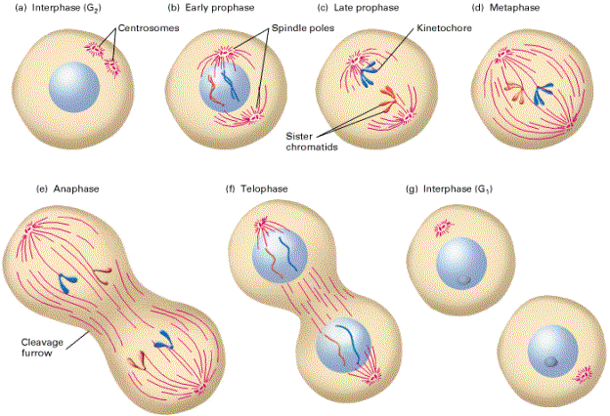

Note: In this course, we do not need to know the difference between early and late prophase, as shown in the diagram .

*Determine and Graph the Theoretical population growth rate of cells, and interpolate and extrapolate the cell population*

* For certain organisms, such as bacteria, the process of mitosis can lead to large populations growing very quickly. For example, 1 bacteria can produce 2 new daughter cells. Those 2 daughter cells can reproduce to form 4 daughter cells, then 8, then 16, then 32 and so on. After only a short amount of time, populations can become massive. This is why we can get very sick just by being exposed to only a few bacteria cells.

*Distinguish between sexual and asexual reproduction in representative organisms*

* **Asexual Reproduction** is the process where an organism reproduces with only one parent. The offspring is genetically identical to it’s parent (with the exception of mutations)

**5 Major types of asexual reproduction include:**

* Binary Fission - A single celled organism produces 2 new daughter cells Algae, Bacteria (IMPORTANT)
* Spore Production - Tiny single cells that can grow into new organisms by mitosis. Examples include Mould, Ferns.
* Budding - An outgrowth or ‘bud’ grows from the parent, and then pinches off to form a new organism. Examples include hydras as well as sponges (like spongebob)
* Fragmentation - When an organism breaks apart, that part may grow into its own organism. Examples include sea stars
* Vegetative Reproduction - Specialized cells in plants form structures that can move outward from the parent and produce an identical plant. Examples include potatoes (potato eyes) as well as plant cuttings.

*Illustrate and describe the basic processes of cell division, including what happens to the cell membrane and the contents of the nucleus*

* **Sexual Reproduction** is the process where sex cells from a male and female produces a genetically unique offspring.
* **A Gamete** is the sex cell produced by an organism. In humans, the male gamete is sperm, and the female gamete is an egg. A gamete has **half** of the genetic information of a regular cell. (23 chromosomes instead of 46 chromosomes in humans)
* **Fertilization** is the process where gametes combine to produce a new cell.
* **A zygote** is the cell produced as a result of fertilization. A zygote will have a full set of genetic information (46 chromosomes in humans)
* **An Embryo** is what results from a zygote after is begins to grow through mitosis.

Gametes contain only half of the genetic information of a regular cell, it is known as a **haploid (n)** cell. A regular body cell has a full set of chromosomes, and therefore is a **diploid(2n)**  cell.

The process of forming sex cells in the body is known as meiosis. Meiosis has 8 major steps, and is broken down into 2 main parts:

Meiosis I:

Prophase 1: Homologous chromosomes pair up

Metaphase 1: Homologous chromosomes line up in the middle of the cell

Anaphase 1: Homologous chromosomes are pulled apart

Telophase 1: Homologous chromosomes move to opposite ends of the cell and begin to divide

Meiosis 2:

Prophase 2: nucleus only contains 1 chromosome from the homologous pair in each cell

Metaphase 2: chromosomes line up at the equator

Anaphase 2 : Half of the chromosomes are pulled to opposite poles

Telophase 2: a nuclear membrane forms around each set of chromosomes and the cell begins to divide to produce **4 haploid gametes**.

*Illustrate and describe the basic process of cell division, including what happens to the cell membrane and the content of the nucleus*

There are many similarities and differences between mitosis and meiosis. The key differences are highlighted below *\*IMPORTANT\**



*Distinguish between sexual and asexual reproduction in representative organisms*

One very important example of sexual reproduction include insects. Many insects undergo a process known as **metamorphosis**. Metamorphosis is a change in the form of an individual

There are 2 Types of Metamorphosis:

1. **Incomplete Metamorphosis** - A process whereby an insect begins as an egg, then develops into a nymph (smaller version of an adult) then finally forms into an adult
2. **Complete Metamorphosis -** A process where an insect start as an egg, then develops into a larva. The larva will form a pupa, and finally will develop into an adult. A good example of this is when the caterpillar (larva) forms a cocoon (pupa) and eventually becomes a butterfly (adult)

Sexual Reproduction can take place either internally or externally. Internal fertilization, like with humans requires sexual intercourse. Other species do not have to have intercourse to reproduce sexually such as many types of fish etc. since the egg and sperm are fertilized outside of the female.

*Compare sexual and asexual reproduction in terms of their advantages and disadvantages*

Sexual and Asexual reproduction are two very different processes, and have many key differences. They are summarized in the table below:



The main benefit of sexual reproduction is that the offspring that are produced are genetically unique to their parents. This helps species adapt to changes in their environment. However, sexual reproduction usually can be more energy intensive in finding a mate, and may require large amounts of parental care.

Asexual reproduction can allow populations to grow very quickly, only require one parent and use little energy. However, since the offspring are identical to parent, they are vulnerable to changes in the environment that can wipe out populations.

*Provide examples of genetic conditions that cannot be cured using scientific and technological knowledge at the present time*

* **Down Syndrome** is a genetic condition where the person has an extra chromosome
* **Cystic Fibrosis**  is a genetic condition that causes a person to have extreme difficulty with breathing and can result in a shortened life expectancy
* **Allerdice Syndrome** is a genetic condition that has been studied in Newfoundland, and has resulted in features such as low birth weight, hand and facial abnormalities, etc.

*Identify major shifts in scientific understanding of genetics*

* **Gregor Mendel** is often referred to as the father of genetics. He was the first person to observe traits, and used pea plants to see how the traits of parents are passed on to offspring
* **Watson and Crick**  were scientists in the 1950s who discovered the structure of DNA. Since the discovery of DNAs structure, many advances in genetics have taken place.
* **The Human Genome Project** was a large scale effort from 1986 to 2003 to decode the entire genome of a human. The entire code of DNA for a person was analyzed, and may lead to many advances in medicine and science in the future.
* **Genetic Engineering** is a field of science that is very important now. Since we know how to manipulate genes, we have to ask ourselves if it is a good idea to mess with the design of nature.