Unit 3 - Electricity
Explain the production of static electrical charges of some common materials
- Static Electricity - The build-up of electric charge of the surface of objects. A static charge does not move, unless it is removed by a ground, or it is discharged. (example: Rubbing a balloon on your head makes static electricity)
- When static electricity is formed, electrons move from one object to another. A neutral object that gains electrons becomes negative, while a neutral object that loses electrons becomes positive. An object that has equal numbers of electrons and protons are neutral.
- Positive charges (Protons) NEVER MOVE. Only electrons move from one object to another.
- When a static charge is removed, it is known as a static discharge. An example of this would be lightning.
Identify the properties of static electrical charges
The Law of Electric Charges states that
- Like charges repel (a positive and a positive, or a negative and a negative)
- Unlike charges attract (a positive and a negative)
- Charged objects attract neutral ones (a positive or negative object will attract a neutral object)
Provide examples of how knowledge of static electricity has resulted in the development of technologies
- Technologies that are based on static electricity include:
  - Lightning Rods
  - Photocopiers
  - Electrostatic Air Cleaners
Qualitatively compare static electricity and current electricity
- Static electricity and Current electricity have 2 major differences between them.
  - Static electricity remains in place, while current electricity is electricity that moves
  - Static electricity cannot be harnessed for power, while we use current electricity to power our homes and devices.
Provide Examples of careers related to electricity in their community and province
- Many jobs are related to use of electricity, including:
  - Photocopier technician
  - Electrician
  - Linesman
  - Electrical Engineer
Describe the flow of charge in an electric circuit using precise language
- Potential Energy is stored energy. Stored energy may be found in a battery, or in other places like in a stretched rubber band, or a rock on top of a hill.
- Electrons have potential energy when they are stored in a battery. The amount of potential energy the electrons have is known as the Voltage. Voltage is measured in volts.
An Electrochemical cell can be used to produce electrical energy. In order to produce a voltage, we need several things:
- 2 Electrodes of different material (different metals, for example)
- Electrolyte( salty water, an orange, Gatorade will all work)
When electrons move in a cell, there are a lot of them. We use the coulomb to measure electrons. 1 Coulomb is equal to 6.28 x 10¹⁸ electrons, or the number of electrons that pass through a 100W lightbulb in 1 second.
- The flow of electricity is known as the electric current. You can think of it as being similar to the flow of cars on a highway, or the flow of water in a river.
- Current is measured in Amps.

Describe the flow of charge in an electric circuit using precise language
An Electric Circuit is a complete path for electricity to take. It has 4 main parts:
- Source of Electricial Energy (Ex. A Battery)
- An electrical load (something to use the energy)
- A switch to turn the circuit on and off
- A conductor to let the electricity to pass through (wires)
The energy source provides electricity for the load to use. The load `uses` the voltage, and the voltage decreases across the load.
When circuits are drawn, it is important that the correct symbols are used to represent different parts of the circuit.
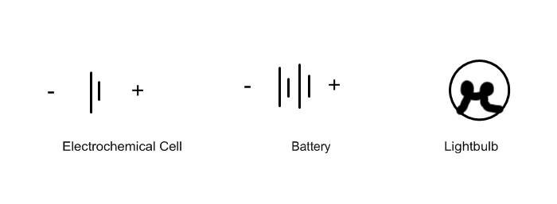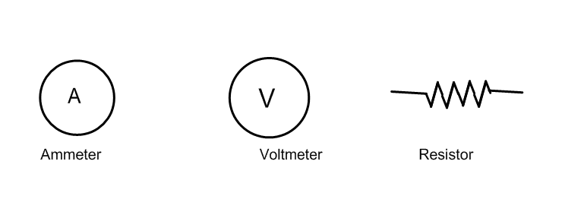
Organize information using a format appropriate to studying and describing current electricity
- Electrical Resistance is the opposition to the flow of electricity. Electricity can be slowed down depending on the conditions. Resistance is measured in Ohms.
- A Resistor is a device that is used to control the flow of electricity. By adding a resistor to a circuit, the current decreases.
- There are 4 main factors that affect the resistance that a wire will have:
  - Type of wire - Different metal types have different resistances
  - Length of wire - The longer the wire, the greater the resistance
  - Thickness of wire - A thin wire has more resistance than a thick wire
  - Temperature - a hot wire has more resistance than a cold wire
Identify new questions and problems that arise from what was learned concerning voltage, current and resistance.
- The relationship between Voltage, Current, and Resistance is stated in Ohm`s Law. It can be written in 3 different ways, depending on what you are trying to find. Note: V = Voltage, I = Current, R = Resistance :
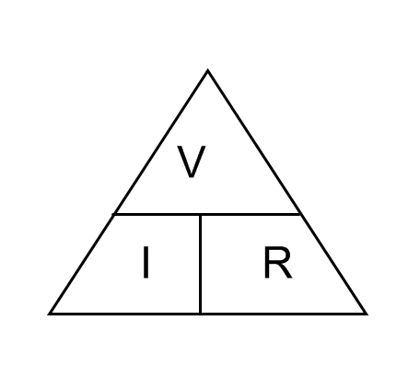
  - V = I x R
  - R = V ÷ I
  - I = V ÷ R
This information can be organized in a triangle like the one shown:

Describe Series and Parallel Circuits involving varying resistance, voltage, and current
- A Series Circuit is a circuit that only has one path for electricity to take.
  - The current in a series circuit is the same throughout
  - The voltage of all loads is shared. Ex. If there are 3 identical lightbulbs attached to a 12V battery, then each bulb will use 4V each.
  - Adding extra resistors in series will increase the resistance.
  - If the circuit is broken at any point, the entire circuit will stop.
  - Examples of series circuits would include a flashlight, many other circuits with only 1 load.
- A Parallel Circuit is a circuit that has several paths that electricity can take.
  - The current in a parallel circuit splits at the junction point, so a portion of the current flows through each parallel path.
  - The voltage through parallel paths is equal, and equals the voltage of the power supply
  - Adding extra resistors in parallel will decrease the resistance
  - If one path of a parallel circuit is broken, the other paths can still work
  - Examples of parallel circuits would include household lights.
Analyze the design of technologies, how they function, and how they impact our daily lives
When electricity enters your home, there are several ways that we can protect the circuits in our households.
A circuit breaker is connected to the meter of your home, and acts as a switch for all the electricity of your home. If the current in your home becomes dangerously high, then the breaker will ‘trip.’ This is caused by a bimetallic strip bending and opening the circuit, stopping the flow of electricity. The circuit can be closed once the breaker cools and can be reset.
Older homes and some appliances still use fuses. A fuse contains a metal conductor that can melt if too much current passes through it. Once a fuse is ‘blown’ it must be replaced.
Fuses and circuit breakers are important because if too much current passes through a circuit, the wires can become very hot and start fires.
A grounding wire or grounding terminal is used on many devices (it is the 3rd prong of a plug) and carries away any current that may ‘leak’ from metal parts of an electrical device, and can prevent giving you a shock.

Relate electrical energy to domestic power consumption costs
Electricity is a form of energy. Electricity is measured in Joules ( symbol J).
When devices use electrical energy, some will use it faster than others. In other words, these devices need more power. Power is measured in watts and is defined as the number of joules used per second.
Power = Joules/Seconds Example: A 60Watt lightbulb uses 60 joules each second.

Another way of thinking about power is that it depends on the flow of electrons (current) as well as the amount of energy each electron has (voltage). Power can be found using the following formula:
P = V x I P = Power V = Voltage I = Current

Calculating Electricity Consumption (IMPORTANT):
To find out how much electricity is used by a device, we need to know 2 main things:
- How much power, in watts, the device uses
- How long the device was used for, in seconds.
Energy = Power x Time Energy is measured in Joules, Power in Watts, and Time in Seconds.

Another way to measure power
When measuring large amounts of power, we usually do not use Joules. Instead, we use the measurement of kilowatt hours. This is what is used to measure your power bill, for example.
To find Power in kilowatt hours, we use the following formula:
Kilowatt hours = # of kilowatts x # of hours

Power and Efficency:
When devices are used, not all the electrical energy provided is turned into ‘useful’ energy. For example, the electricity provided to an electric lawnmower can be turned into mechanical energy (useful) but also heat and sound energy (waste energy).
Being energy efficient has become much more important in the past number of years because of environmental concerns as well as costs of electricity. Wasting electricity can cost consumers money, and producing electricity can be harmful to the environment.
Energuide is a system used to help consumers to select appliances that are the most energy efficient

When we are deciding if we are being efficient with electricity, we can calculate efficiency.
Efficency = Useful energy x 100%
Total energy used

Producing and Transporting Electricity:
The main way to produce electricity is using a generator. A generator produces electricity by passing a magnet through a coil of wire. A generator is used to produce electricity from a number of energy sources:
- Hydro electricity 2. Wind Power 3. Nuclear Power

When electricity is transferred from one place to another, it is transported at high voltage and low current . This ensures that the electricity is transferred as efficiently as possible.
A transformer is a device used to change the voltage of electricity. A transformer may be used to ‘step up’ the voltage of electricity when it leaves the generating station, or it may be used to ‘step down’ the voltage, like the transformers near your home.

1. Using the diagram shown below, explain what happens to Object A and B after they are rubbed together. Be sure to indicate the objects current charges and charges after rubbing. (Note: Object B has a strong attraction for electrons)

2. Draw each of the following series circuits
a. 1 bulb, 1 resistor, a voltmeter, a battery and 1 closed switch
b. 2 bulbs, 1 resistor, an ammeter, a battery and 1 opened switch
3. Draw each of the following parallel circuits
  - 2 bulbs, 1 battery, 1 closed switch and 1 opened switch
  - 4 bulbs, 1 battery, 4 resistors, 2 opened switches and 2 closed switches
4. A 12 V battery requires 3 A of current. What resistance is going through this circuit?
5. You require your circuit to have 16 Ω of resistance but you only have an 8 V battery. How much current can the system take?
6. If the same system needs 15A and16 Ω run an appliance, what voltage of appliance can you use?
7. How much power is used by a 1500 V saw running on a 12 A current?
8. A scooter has a 25 A fuse attached to it. If it runs off a 110 V motor, what kind of power does the scooter have?
9. Convert the following:
  - Change 1450 W to kW
  - Change 21000 W to kW
  - Change 24 minutes to hours
  - Change 156 minutes to hours
10. How much electrical energy is consumed by a 45kW washer left running for 45 minutes?
11. How much electrical energy is consumed by a 7500W toaster that is used at the breakfast program for 0.5 h?
12. You use a hair dryer for 0.4 h to dry your hair and it uses 65.5kW of electricity. If the cost of electricity is 9.512 cents/kWh, how much does it cost you to dry your hair?
13. You run a 1000 V dryer on 25 A of current for 3 hours. The cost of running the machine is 9.512 cents/kWh. How much does it cost you?
14. A regular light bulb uses 4.5 kWh of energy to supply 1 kWh of light for 1 hour. A incandescent light bulb uses 8.3 kWh of energy to supply 1.4 kWh of light for 1 hour. Which light bulb is more efficient?
15. Which radio would you recommend?
  - Radio A: uses 26 kWh to produce 4.5 kWh of radio for an hour
  - Radio B: used 5 kWh to produce 2.2 kWh of radio for an hour

